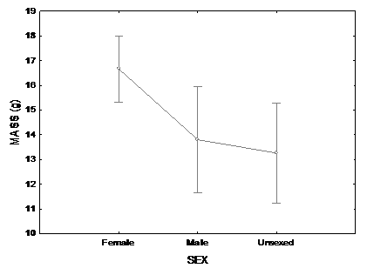
Figure 2 – Average body mass (± SD) by sex and indeterminate animals of two samples of Nile Tilapia Supreme strain undergoing sex reversal in treatment at 25°C. First sampling (112 after hatching).
Body mass (g)

