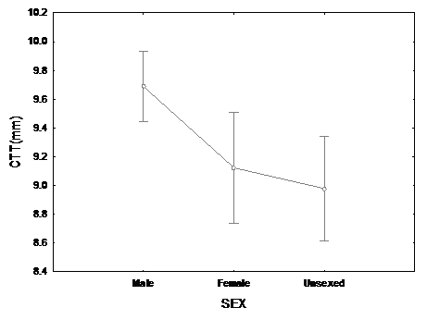
Figure 3 - Average total length (± SD) by sex and indeterminate animals of two samplings of Nile Tilapia Supreme strain undergoing sex reversal in treatment at 25° C. First sampling (112 after hatching).
TL (mm)

