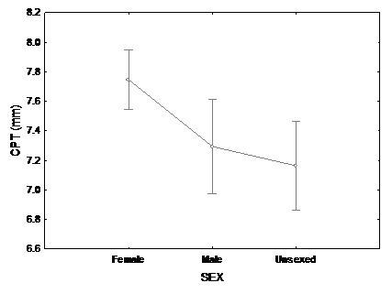
Figure 4 - Mean standard length (± SD) by sex and indeterminate animals of two samplings of Nile Tilapia Supreme strain undergoing sex reversal in treatment at 25° C. First sampling (112 after hatching).
SL (mm)

